Fundamentals Course Homework
Due Date: October 17, 2024
Session 1
In this session, we’ve talked about developing a plan or roadmap for the implementation of a BR&E program. Given the planning model shown on Slide 9 of the presentation in Section 3, describe your (or your EDO’s) vision of the outcomes, outputs, and inputs required to create an atmosphere of success for the program. Note that we’re not asking for specific numbers (i.e., budget line items, numbers of employees, etc.), but rather a narrative of what should be considered when addressing each component of the planning model.

As a new Chamber director in a community that has had a tumultuous relationship with the local Chamber and other Economic Development Organizations, I am looking for opportunities to truly understand the needs and the desires of the local business community and make a plan to strategically move forward on critical issues.
With our situation, I would collaborate with the other local organizations and implement a traditional continuous visitor model that helps us understand both the company specific needs and the needs of the greater community. From this starting point, I would then create a strategic plan that identifies the mid- and long-term solution for the desired outcomes.
This strategic plan would help to prioritize activities and initiatives, as well as source additional funding through private donation and/or grants to support our goals.
This community has historically been opportunistic vs. strategic, which has led to disjointed efforts and unintended consequences. I am encouraged that an actual plan based on relationships with stakeholders will provide a clear path to success and keep us from responding to quickly to distractions.
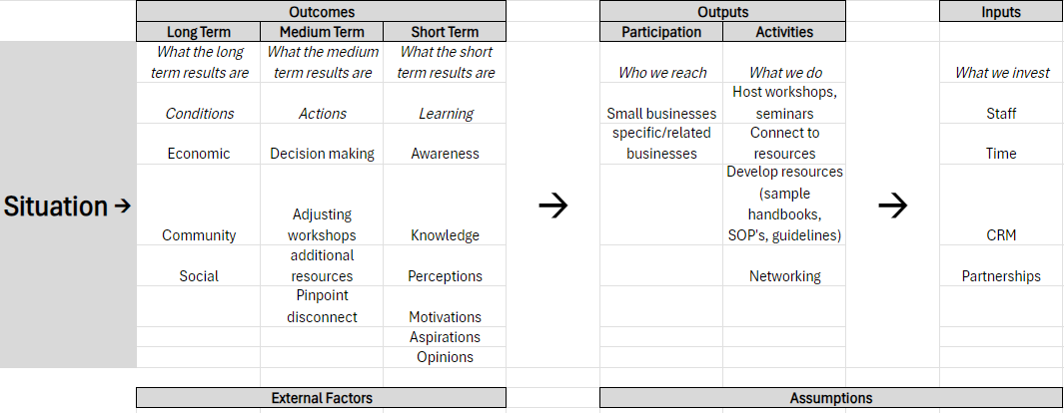
Background: Partnership Grand Strand (PGS) is the nonprofit arm of our local/area Chamber of Commerce. We are funded by area businesses to help accelerate the prosperity of the Grand Strand area (Horry County & Georgetown County in SC). Our focus is on 4 pillars: workforce, prosperity, infrastructure and place. My focus, specifically, is the prosperity pillar which mainly focuses on the small businesses in our area. This is also the pillar that our BR&E surveys fall under. Our survey was created to be in alignment with what our city and area economic development have requested while speaking with the small business community. The survey results will be used to help us provide support, programming, and resources for our small business community which consists of over 8,000 businesses. We recently held a seminar based on some initial survey results; however, the turnout was dismal at best. So while we felt like we were delivering what the business community had asked for, we fell very short of achieving our goal to have 15 businesses at the event. As we continue to reach out to more businesses, we realize that there is still a disconnect that remains within the business community. Trying to pinpoint where the disconnect lies has become a focus point when meeting with businesses to complete surveys.
Outcomes Section
Long Term:
The City of Austin’s BRE Program is to maintain an economic development strategy to work with our existing businesses. The long-term results are that we are strengthening relationships between businesses and the community while supporting their growth and sustainability in Austin. Rather than merely conducting surveys, DECA members (Chambers of Commerce) are engaging in meaningful discussions with small, medium and iconic/legacy businesses to identify plans for expansion, challenges impacting their ability to remain in Austin, and workforce skill gaps. The contractors are connecting these businesses with City resources, particularly those offered by the Economic Development Department (EDD), Small Business, Workforce, Childcare, Community Technology, or Global Business teams. By continuing to leverage these resources, the EDD is generating a positive economic multiplier effect.
Medium Term:
The medium-term results are that we have set a goal conducting a minimum of 750 interviews annually with the four chambers of commerce partners. We have recruited staff from the University of Texas at Austin, Austin Community College, City of Austin’s Economic Development, Small Business Programs, Strategic Planning/Data Team, Austin Area Urban League, Workforce Solutions. We would begin compiling a target list of Large, Medium, Small, and Iconic businesses to begin setting up of appointments for visitation.

Short Term:
The short-term results are that we have set a goal to actively conduct a minimum of 15 visitation interviews per month by each of the four chambers of commerce partners for a total of 60 interviews per month or 180 per quarter. During round #1 of in-person interviewing, we will gather company-specific issues to look for systemic issues facing companies who operate in our city, to know the pressures they face, discover other local factors. Our prioritization will be with large employers. During round #2 of in-person interviewing we will take on Austin’s Iconic and small businesses in general. that have a special attachment and meaning for Austin and its citizens. During Round #3 the of the in-person interviewing we will glean medium company issues to look for systemic issues facing them those who operate in our city, to know the pressure they face, and discover other local factors.

Outputs Section
Whom we reach:
Fortune 500 companies that reside in Austin, Texas. The Fortune 500 is an annual list compiled and published by Fortune magazine that ranks 500 of the largest United States corporations by total revenue for their respective fiscal years. The list includes publicly held companies, along with privately held companies for which revenues are publicly available.
A small business is a privately owned business that is independently operated and has fewer employees and less annual revenue than a regular-sized business. The Small Business Administration (SBA) defines a small business in the United States based on industry-specific standards: For example, manufacturing and mining businesses have a maximum of 500 employees, while wholesale trade businesses have a maximum of 100 employees.
Definition of the Iconic or Heritage businesses that are in Austin, Texas
An iconic business is a brand that is instantly recognizable, authentic, and rare, and is associated with innovation and widespread admiration. Iconic brands are cultural phenomena that create emotional connections with their customers and are often a sign of success and sustainability.

What we do:
The contractor must ensure that assigned GACC staff complete the BRE Fundamentals Course provided by Business Retention and Expansion International, or a similar organization, no later than a certain date, to begin interviews promptly in January. This will allow the GACC to engage with businesses early in the year and avoid delays. The contractor will report the scheduled training date and provider to EDD’s BRE Coordinator. The contractor will collect data through in-person surveys and interviews with targeted businesses by January 15, 2025, and provide the information to EDD’s Data Team. During these interviews, the contractor must gather specific business data points, including:
  - Employment numbers (current and planned expansions)
  - Revenue growth (year-on-year)
  - Capital investment (in existing or new facilities)
  - Industry sector breakdown (key sectors)
  - Business closures (risks or confirmed closures)
  - Job creation rates (new positions created)
  - Expansion plans (short- and long-term)
  - Workforce skill gaps (areas where businesses struggle to find talent)
  - Customer satisfaction levels (feedback on City services)
  - Number of businesses contacted, number of employees, and industry
  - District or area of business location within Austin
Additionally, interviews should include discussions on workforce trends and skill needs, in coordination with EDD’s Workforce and Childcare development programs, to ensure a holistic view of business challenges. These insights are essential for understanding both short-term and long-term business needs and for shaping future City initiatives. The contractor is expected to contact 15-20 businesses per month as part of ongoing outreach efforts.
Scheduling and Interviews:
The contractor will schedule interviews with businesses and notify EDD’s BRE Coordinator to ensure a city representative is present for each engagement. This representative will assist in connecting businesses with City resources. EDD and the GACC will collaborate to analyze data in real-time and identify early intervention opportunities.
Reporting and Dashboard:
The contractors will document key business insights from each interview, while EDD will maintain a live dashboard reflecting aggregated business data and trends. The contractor is required to submit a quarterly report detailing:
  - Quantitative data: Employment figures, revenue growth, job creation rates, business expansions, number of businesses contacted, and other metrics.
  - Qualitative data: Business challenges, workforce skill gaps, customer satisfaction, and feedback on City/EDD engagement.
This data will inform City actions, enabling EDD to determine which businesses require additional support. The contractors must also identify trends and skill gaps in their reports, which EDD will use to enhance city-wide resource allocation, workforce development, and strategy adjustments.
Follow-up and Action Items:
Within one week after each interview, the contractor will follow up with businesses to address outstanding action items and ensure that both the GACC and EDD have fulfilled their commitments. The contractor is expected to connect businesses with City services (workforce development, childcare, technology, small business, global business), and EDD will lead the coordination of follow-up activities to ensure businesses receive the support they need.
Positive Engagement:
The contractor is expected to leave a positive impression with each business, reinforcing the value and support provided by both DECA members and the City.
Inputs Section
What we invest
We invest in the DECA organization which is comprised of minority chambers of commerce. They are as follows: Austin LGBT Chamber, Greater Austin Asian Chamber, Greater Austin Black Chamber, Greater Austin Hispanic Chamber. Cumulatively we invest approximately $839,000 in consulting agreement costs. The consulting agreements will be used directly for the purpose of performing BRE activities. In some of these communities there are deep unemployment rates among residents, and issues and trends we may not bring into the light. When we look at the political ramifications of failing to deeply assist these various segments of our communities, we miss opportunities to see issues, resolve trends, and enhance communities within the city of Austin.
One existing business we have in town that I’d like to reference during this exercise is Beauty Bliss, they offer med spa services and a small boutique with custom make up. This BRE program came to our notice while on a routine site visit to discuss the challenges facing their business currently. They expressed a desire to send their staff to classes that would bring them to the forefront of spa services i.e. facials, eyebrow waxing and tinting etc. Through a deeper dive into the issues, we found that they would be able to invest in staff thusly retaining them, increase customer base by expanding product lines and spa services, and serve as the premiere spa in Matagorda County delivering the latest and greatest in spa services.
Situation
- Worker retention
- Everchanging business environment
Outcomes
- Long Term
  - Employee retention
  - Relativity in ever changing market
- Medium Term
  - Expand services offered
  - Diversification of business
- Short Term
  - Outlining with business owner the latest and greatest
  - Narrowing the scope of that the business owner wants
Outputs
- Participation
  - Existing business owners of 1 year or more
- Activities
  - Target local volatile industries
  - Site visits and owner discussion
Inputs
- Reimburse business up to $1,500 for up to 3 employees per physical year or $1,500 to bring in training for the entire staff. This is a Continuing education grant. The business will complete the application. The board will review the application and Training that will be attended. Once approved they must present the certificate of completion to receive reimbursement.
- Long Term
- Businesses can see that we are dedicated to being their partners in creating opportunities rather than obstacles. We strive to reduce red tape and provide them with valuable resources that facilitate their growth. By collaborating closely with businesses in our area we gain a deeper understanding of their needs, enabling us to provide long-term assistance that ultimately helps them thrive. This sustained support fosters an environment where local companies can prosper and succeed.
- Medium Term
- By concentrating on specific industries within our area we can strategically identify the support they need. This targeted approach allows us to tailor our resources and initiatives. This ensures we effectively address the unique challenges and opportunities faced by each sector.
- Short Term
- The survey pre-selected 150 local businesses to complete our annual survey. This targeted approach deepens our understanding of the needs of industry, workforce, and concerns within the community. With the insights gathered, we can create informative newsletters and engaging social media posts to keep businesses updated on events and available resources. To foster further connections, we follow up with a thank-you email and a brief visit to check in on their progress.
- Outputs (develop programs, create events to network, training, surveys, create directories)
- Our team organizes business visits and hosts lunches throughout the year. An annual survey of local businesses identifies their needs and opportunities, providing valuable insights. This allows us to compile a comprehensive list of businesses, complete with contact information, to effectively share our services.
- We monitor visits, complete surveys, and community assessment data to guide our decision-making. As we conducted the same survey we received constant feedback. Based on this information, we are developing programs and resources aimed at supporting business owners in achieving success.
- Inputs (resources and funding, data collection, engagement)
- Our department consists of a dedicated team, with one or two staff members assigned each year to oversee the program from start to finish. We proactively engage with our flagged businesses—specifically those identified as red, green, and yellow. For businesses marked as red, we prioritize immediate outreach to initiate conversations, aiming to deepen our understanding and expand our support efforts. We provide various resources including grants to support our business
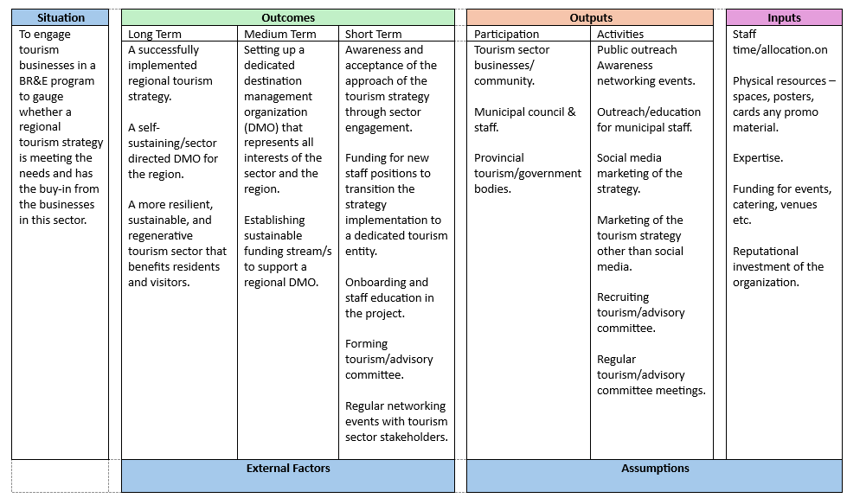
Situation
In the City of Oakland Park, we’re committed to understanding the challenges our local business owners face—whether it’s navigating regulations, securing financial support, or business growth and development. We want to help by providing useful information, launching new initiatives, and hosting events that connect business owners with the resources they need. Our goal is to make sure they feel supported and can grow alongside the community as the city continues to develop.
Outcomes
• Long-Term: Our long-term goal is to create a stable, vibrant business environment in Oakland Park. We envision more businesses staying and growing here, new businesses opening, and a stronger economy overall within the CRA and QCT areas.
• Medium-Term: In the medium term, we want to see businesses actively participating in city programs and initiatives, taking advantage of incentives and grants, and collaborating with other local businesses. We want business owners to feel empowered to seek support from the CRA and the Economic Development department and get involved in city-hosted events.
• Short-Term: The short-term focus is on raising awareness. We’ll educate them on the resources available through Oakland Park’s CRA and Economic Development Department, such as grants, permit assistance, and other incentives and marketing initiatives.
Outputs
• Participation: We’ll focus on reaching local business owners, potential entrepreneurs, and other key stakeholders in Oakland Park. Outreach will target businesses of all sizes, especially those in the CRA, QCT and Special Interest Areas (SIA) where revitalization is a priority.
• Activities:
o Hosting business forums and workshops.
o Offering one-on-one consultations for business owners.
o Launching marketing campaigns like our Find It in Oakland Park to boost visibility for local businesses.
o Increasing opportunities for business owners to participate in city-sponsored special events.
Inputs
• Human Resources: CRA and Economic Development staff.
• Financial Resources: Funding from the CRA and the City to support business incentives, marketing, initiatives, and events.
• Partnerships: Collaborations with partner organizations to provide expertise and support to local businesses.
• Technology:
o Social Media: Platforms like Facebook and Instagram will help promote city programs, events, and business resources.
o Email Blasts: Regular newsletters will keep business owners informed.
o Websites: The CRA and economic development websites will serve as key resources for business owners.
o GIS Tools: We’ll use GIS to map CRA QCT areas for internal planning and external business support.
o Business Clusters/ Special interest Areas: Identifying industry clusters or SIAs to better target support and encourage collaboration.
o CRM Systems: A CRM will track interactions with business owners, ensuring follow-ups and personalized outreach.

