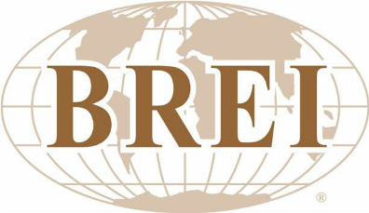
Participant List
October 15-24, 2024

Sarah Dahlstrom
Partnership Grand Strand
122 N. Oak Street
Myrtle Beach, SC 29577
Sarah.Dahlstrom@partnershipgrandstrand.com
(843) 267-5474

Elizabeth Edwards
Economic Development Officer
The City of Quinte West
7 Creswell Drive
Trenton, ON K8V 5R6
elizabeth.edwards@quintewest.ca
(613) 921-8526

Cesar Gonzalez
Director, Trade and International Partnerships
City of Oakland Park
5399 N. Dixie Highway, Suite 3
Oakland Park, FL 33334
cesar.gonzalez@oaklandparkfl.gov
(954) 740-3926

Neysa Herrera
CRA & Economic Development
City of Oakland Park
5399 N. Dixie Highway, Suite 3
Oakland Park, FL 33334
neysah@oaklandparkfl.gov
(561) 563-2545

Lucille Hooper
Economic Development Coordinator
County of Grande Prairie
1001 84th Avenue
Clairmont, AB T8X 5B2
lhooper@countygp.ab.ca
(403) 793-0467

Adam Kemp
Valley Regional Enterprise Network
448 Main Street
Kentville, NS B4N 1K8
businessnow@valleyren.ca

John Leurdyke
Economic Development Officer
35 Commercial Street, Suite 208
Truro, NS B2N 3H9
john@trurocolchester.ca
(902) 957-7827

Dusty McCormick
Economic and Business Development
City of Austin
P.O. Box 1088
Austin, TX 78767
dusty.mccormick@austintexas.gov
(512) 974-7825

Lynn Silver
Valley Regional Enterprise Network
448 Main Street
Kentville, NS B4N 1K8
workforce@valleyren.ca

Ashley Talasek
Bay City Community Development Corp.
1112 7th Street
Bay City, TX 77414
atalasek@cityofbaycity.org
(979) 245-8081

Jennifer Thoma
Executive Director
Cody Country Chamber of Commerce
836 Sheridan Avenue
Cody, WY 82414
jennifer@codychamber.org
(307) 586-1571

